
ITA1403 - ETHICAL HACKING

LAB EXPERIMENTS 1 – 10

192321047
KAUSHIK NARAYANAN V

1. Execute and display the results for the following commands in Kali Linux Operating
Systems:
rm command
users command
tree command

Aim
To execute basic Linux commands rm, users, and tree in Kali Linux.
Commands
1. rm – Remove a file
touch test.txt
ls
rm test.txt
2. users – Display logged-in users
users
Output:
kali
3. tree – Display directory structure
tree
Sample Output:
.
├── Desktop
├── Documents
├── Downloads
├── Music
├── Pictures
└── Videos

Result
Thus, the rm, users, and tree commands were successfully executed in Kali Linux.

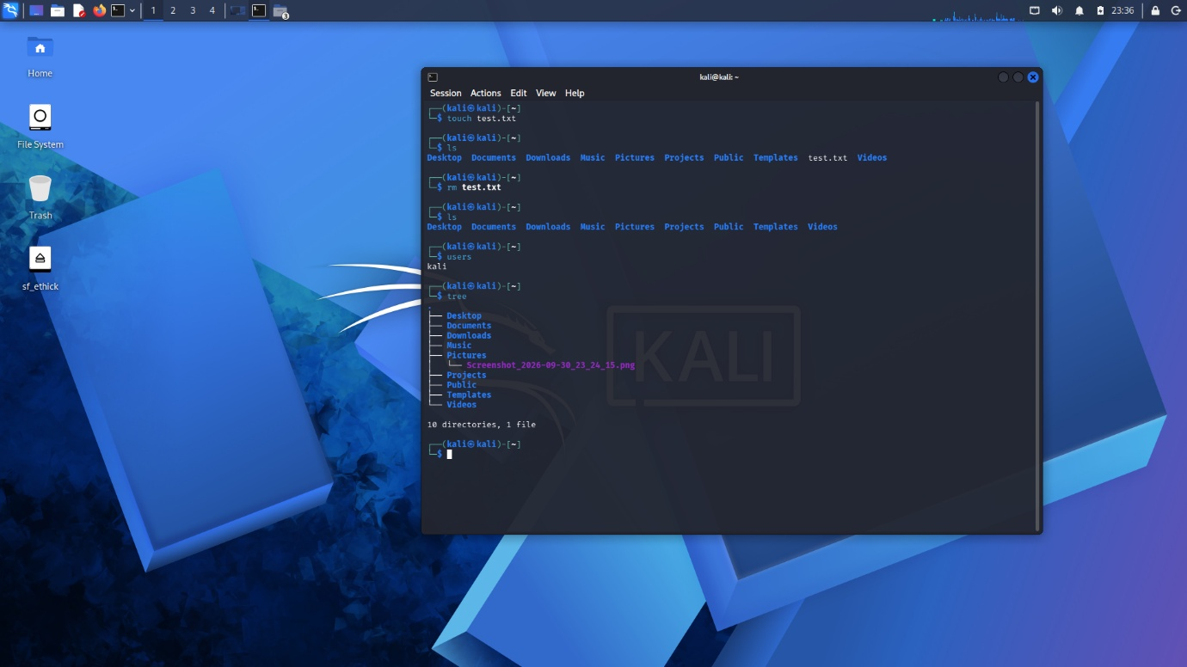

2. Execute and display the results for the following commands in Kali Linux Operating
Systems:

less command
more command
vi command
Aim
To execute and study the less, more, and vi commands in Kali Linux.
1. less Command
Used to view a file page by page.
echo "This is line 1" > sample.txt
echo "This is line 2" >> sample.txt
echo "This is line 3" >> sample.txt
echo "This is line 4" >> sample.txt
echo "This is line 5" >> sample.txt
less sample.txt
Output:
This is line 1
This is line 2
This is line 3
This is line 4
This is line 5

Exit:q
2. more Command
Used to display the contents of a file page by page.
more sample.txt
3. vi Command
Used to create and edit a text file.
vi test.txt

Inside vi:
i
Type:
Kali Linux Operating System
Linux Commands
This is a vi editor demonstration
Then:
Esc-Exit Insert mode
:wq-Save + Quit
Enter
Finally:
cat test.txt

To save and exit: Press Esc, type :wq, then press Enter.
Result
Thus, the less, more, and vi commands were successfully executed in Kali Linux.
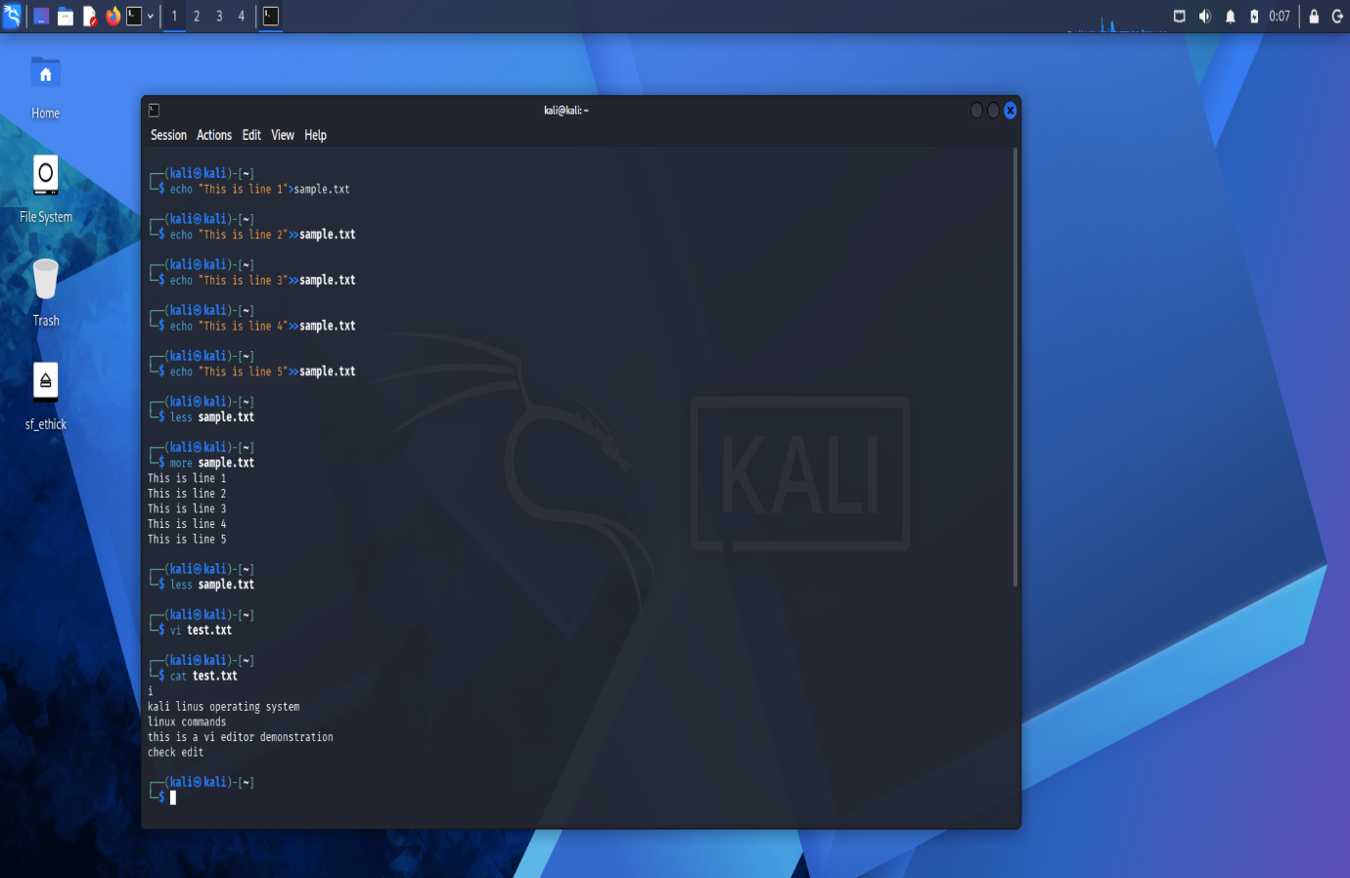

3. Execute and display the results for the following commands in Kali Linux Operating
Systems:
Tree, Head, Tail
Aim
To execute and study the tree, head, and tail commands in Kali Linux.
1. tree Command
Used to display files and directories in a tree structure.
tree
2. head Command
sample file create
nano test.txt
Line 1
Line 2
Line 3
Line 4
Line 5
Line 6
Line 7
Line 8
Line 9
Line 10
Save: Ctrl + O → Enter
Exit: Ctrl + X
Used to display the first lines of a file.
head test.txt
Specific number of lines:
head -n 5 test.txt
Output:
Line 1
Line 2
Line 3
3. tail Command
Used to display the last lines of a file.
tail test.txt
Line 1
Line 2
Line 3
Line 4
Line 5

for i in {11..20}; do echo "Line $i" >> test.txt; done
tail test.txt
Line 11
Line 12
Line 13
Line 14
Line 15
Line 16
Line 17
Line 18
Line 19
Line 20
cat test.txt
Print the content of the sample file
Result
Thus, the tree, head, and tail commands were successfully executed in Kali Linux.
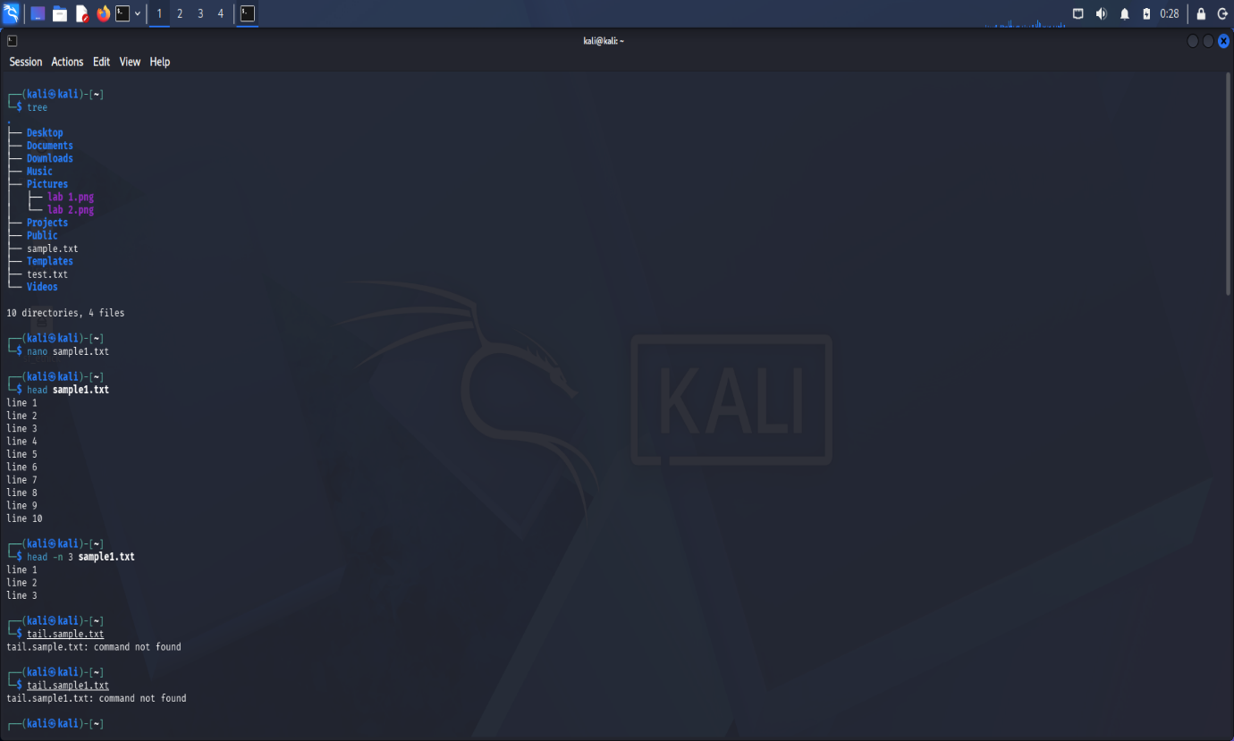
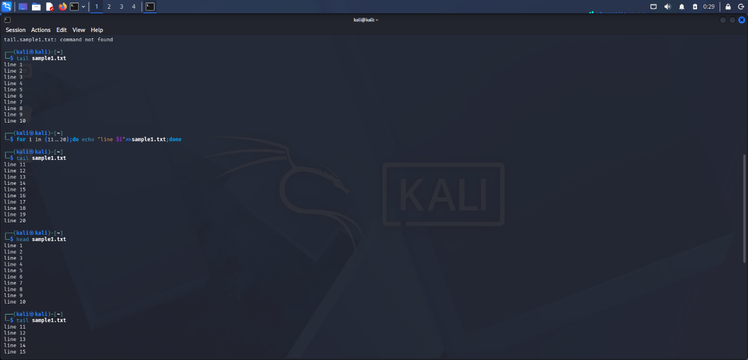
4. Execute and display the results for the following commands in Kali Linux Operating
Systems:
i) Ls
ii) Cat
iii) Mkdir
Aim
To execute and study the ls, cat, and mkdir commands in Kali Linux.
1. ls Command
Used to list files and directories.
ls
2. cat Command
Used to display the contents of a file.
cat test.txt
3. mkdir Command
Used to create a new directory.
mkdir testfolder
Verify:
ls
Remove folder:
rmdir testfolder
ls
Result
Thus, the ls, cat, and mkdir commands were successfully executed in Kali Linux.
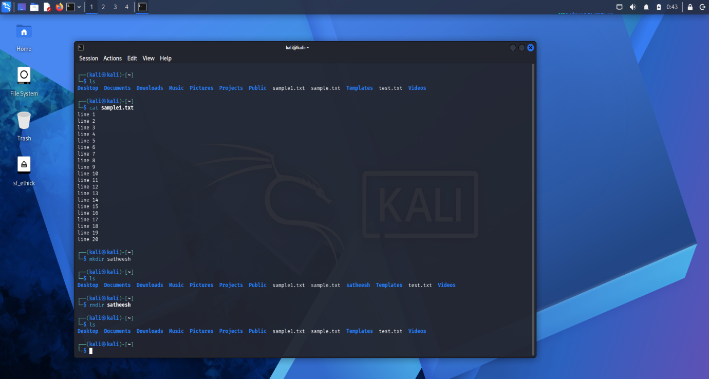

5. Execute and display the results for the following commands in Kali Linux Operating
Systems:
i) Uptime
ii) Date
iii) Mv
Aim
To execute and study the uptime, date, and mv commands in Kali Linux.
1. uptime Command
Used to display how long the system has been running.
uptime
2. date Command
Used to display the current date and time.
date
3. mv Command
Used to move or rename a file.
MV
echo "This is a move command demonstration" > oldfile.txt
ls
mv oldfile.txt newfile.txt
ls
Result
Thus, the uptime, date, and mv commands were successfully executed in Kali Linux.
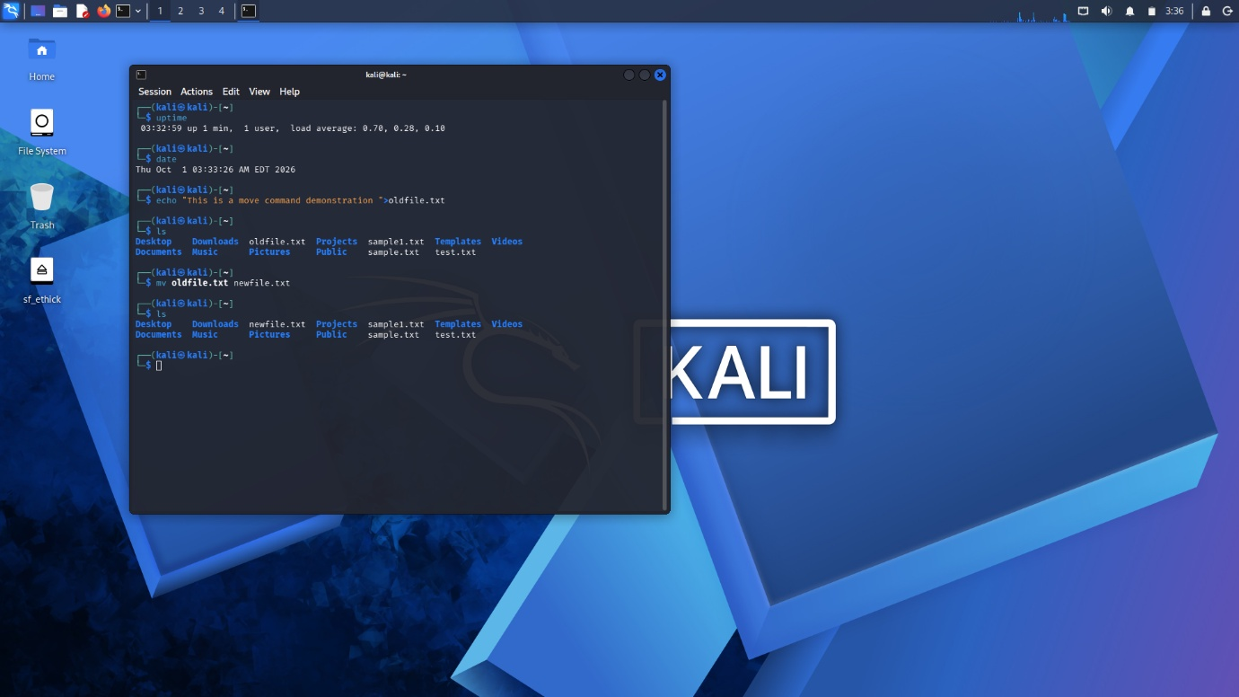
6. Execute and display the results for the following commands in Kali Linux Operating
Systems:
i) Touch
ii) Pwd
iii) Wget
Aim
To execute and study the touch, pwd, and wget commands in Kali Linux.
1. touch Command
Used to create a new empty file.
touch test.txt
2. pwd Command
Used to display the current working directory.
pwd
3. wget Command
Used to download files from the internet.
wget https://images4.alphacoders.com/135/1352902.jpeg
Ls
Then downloaded image:
xdg-open image.jpg
Result
Thus, the touch, pwd, and wget commands were successfully executed in Kali Linux.
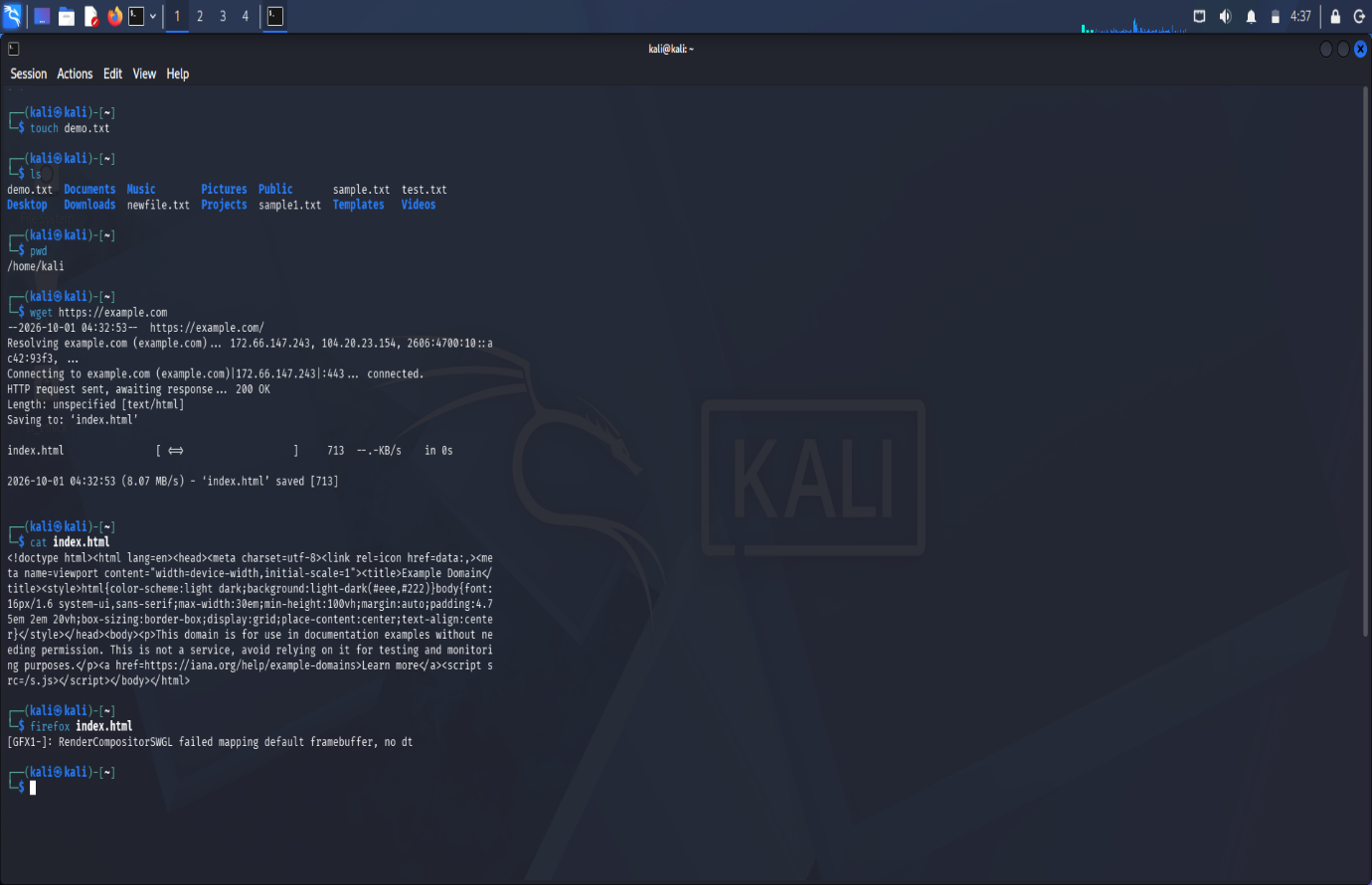

7. Execute and display the results for the following commands in Kali Linux Operating
Systems:

Cd
Cp
ls
Aim
To execute and study the cd, cp, and ls commands in Kali Linux.
Procedure
- Open the Kali Linux Terminal.
- Execute the given commands one by one.
- Observe and verify the output.
Commands
i) cd
pwd
cd Documents
pwd
cd ~ (home)or cd ..(previous)
ii) cp
echo “just try “>test.txt
cp test.txt test copy.txt
cat copy.txt
iii) ls
ls
Result
Thus, the cd, cp, and ls commands were successfully executed and the results were displayed in Kali Linux.
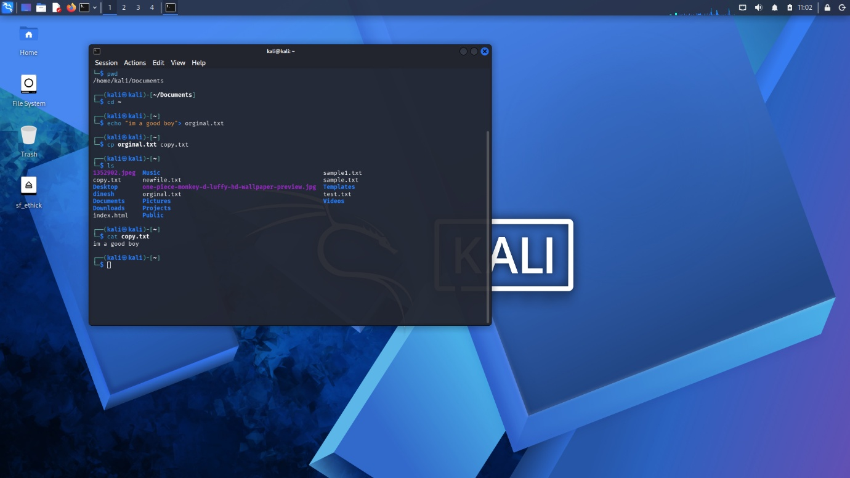

8. Execute and display the results for the following Nmap service version and OS
detection commands in Kali Linux operating systems:
i) detect the version of services running
ii) aggressive scan
iii) detect operating system of the target

Aim
To execute Nmap service version detection, aggressive scanning, and operating system detection commands in Kali Linux.
Procedure
- Open Kali Linux Terminal.
- Execute the Nmap commands one by one on the local system.
- Observe and record the results.
Commands
i) Detect the version of services running
nmap -sV 127.0.0.1
Output: Displays detected service versions on open ports. If no ports are open, it may report that all scanned ports are closed.
ii) Aggressive scan
nmap -A 127.0.0.1
Output: Attempts service detection, OS detection, default scripts, and traceroute.
iii) Detect operating system of the target
sudo nmap -O 127.0.0.1
Output: Attempts to identify the target operating system. OS detection may be inconclusive if insufficient information is available.
Result
Thus, Nmap service version detection, aggressive scanning, and operating system detection commands were executed in Kali Linux.
Note: 127.0.0.1 means your own Kali system (localhost). Use these scans only on systems you own or have permission to test.
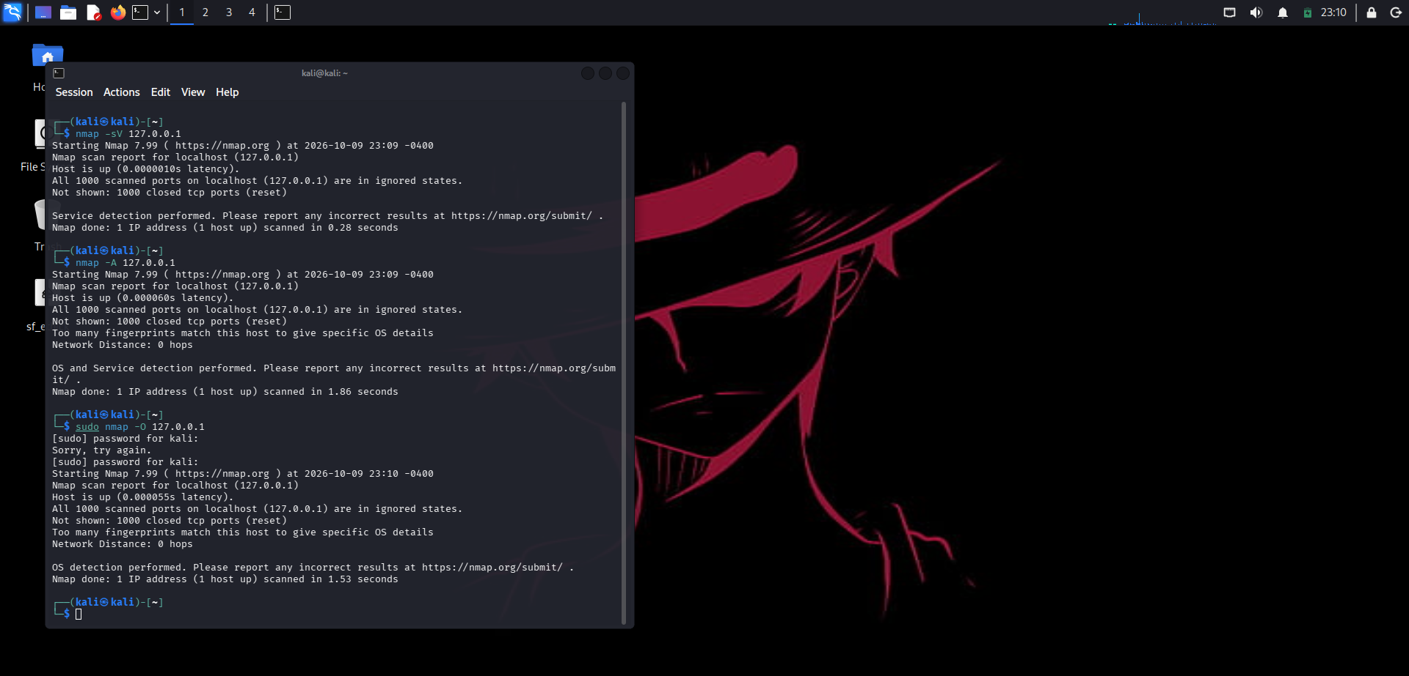
9. Execute and display the results for the following Nmap Timing and performance
commands in Kali Linux operating Systems:
(i) polite IDS evasion
(ii) normal IDS evasion
Aim
To execute and study Nmap timing options used for polite and normal scanning in Kali Linux.
Procedure
- Open Kali Linux Terminal.
- Run the following commands against your own system or an authorized lab target.
- Observe and record the output.
Commands
i) Polite scan (T2)
nmap -T2 127.0.0.1
Output: Performs scanning at a slower rate to reduce network load.
ii) Normal scan (T3)
nmap -T3 127.0.0.1
Output: Performs scanning at the default timing speed.
Result
Thus, Nmap timing options -T2 (polite) and -T3 (normal) were executed in Kali Linux.
Note : -T2 and -T3 are timing templates; they are not IDS-evasion guarantees. Use them only in an authorized lab environment.
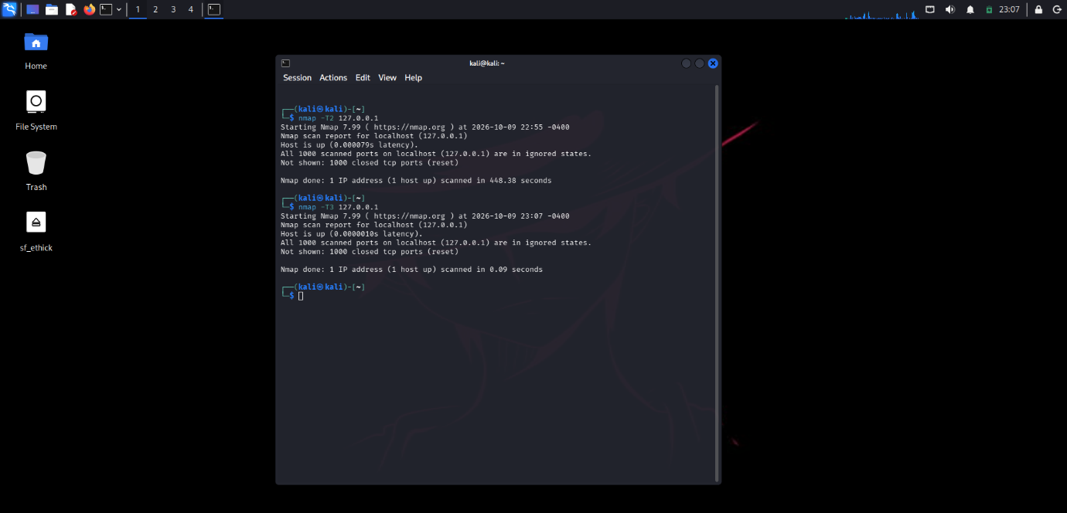
10. To execute the following commands in Kali Linux Operating Systems:

Free command
Sort command
History command
Aim
To execute and study the free, sort, and history commands in Kali Linux.
Procedure
- Open the Kali Linux Terminal.
- Execute the given commands one by one.
- Observe and record the output.
Commands
i) free command
Used to display memory usage.
free -h
ii) sort command
Used to sort the lines in a file.
sort names.txt
iii) history command
Used to display previously executed commands.
history
history 10
Result
Thus, the free, sort, and history commands were successfully executed in Kali Linux.
